SQL DAY2 LAB Assignment

1. Create table named department with following columns

(Dep_id int,

dep_name varchar,

dep_location varchar )

a. Add primary key to Dep_id column

b. Add Default constraint to dep_location with default value

‘Mumbai’

c. Add NOT NULL constraint to dep_name column

ANSWER:=>

command=>create table department

-> (

-> Dep_id int,

-> dep_name varchar(200) NOT NULL,

-> dep_location varchar(200) DEFAULT 'Mumbai',

-> PRIMARY KEY(Dep_id)

-> );

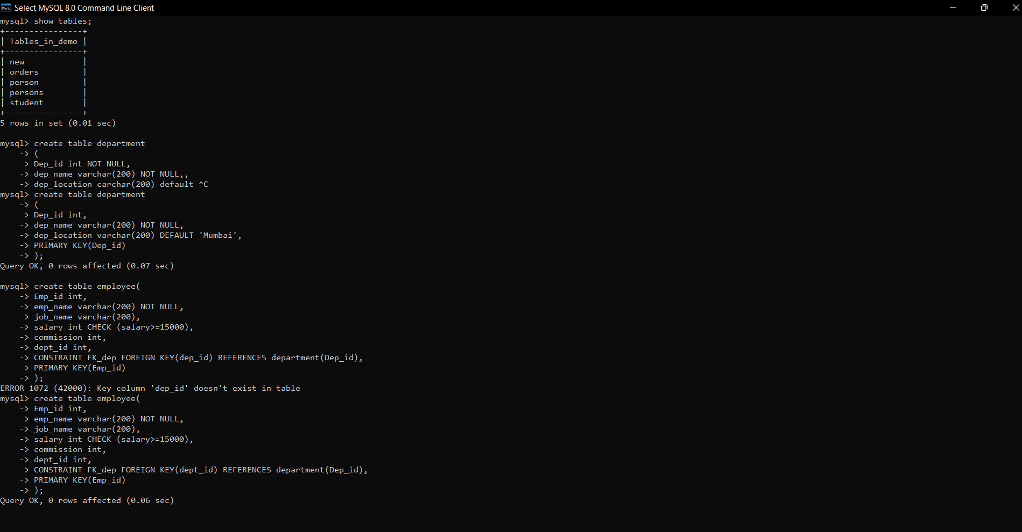

2. Create table named Employee with following columns

(Emp_id int,

emp_name varchar,

job_name varchar,

salary int,

commission int,

dep_id int )

a. Add primary key to Emp_ID column

b. Add foreign key to dep_id column in employee table referring

department column primary key

c. Add check constraint to salary column where salary greater than or

equal to 15000

d. Add NOT NULL constraint to emp_name column

Command=> create table employee(

-> Emp_id int,

-> emp_name varchar(200) NOT NULL,

-> job_name varchar(200),

-> salary int CHECK (salary>=15000),

-> commission int,

-> dept_id int,

-> CONSTRAINT FK_dep FOREIGN KEY(dept_id) REFERENCES department(Dep_id),

-> PRIMARY KEY(Emp_id)

-> );

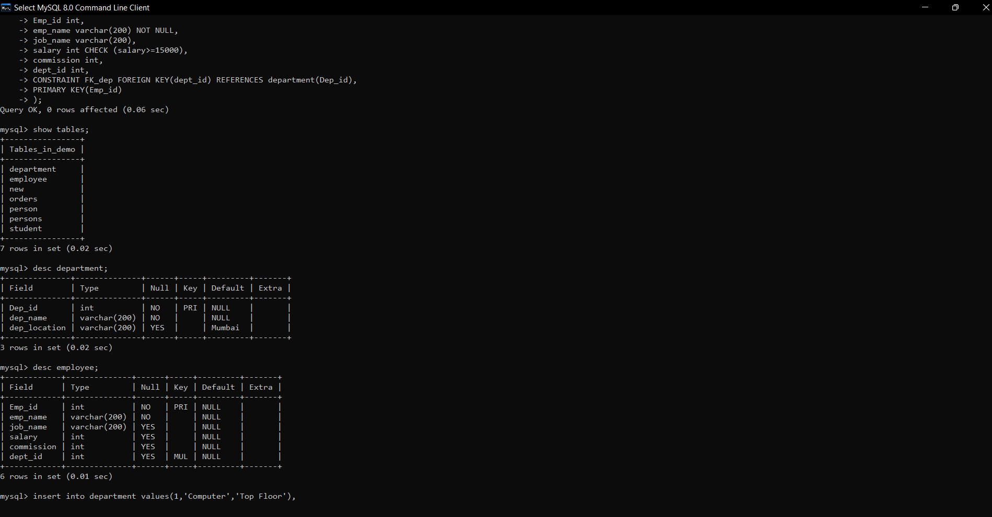

3. Insert 5 Different records in Department table

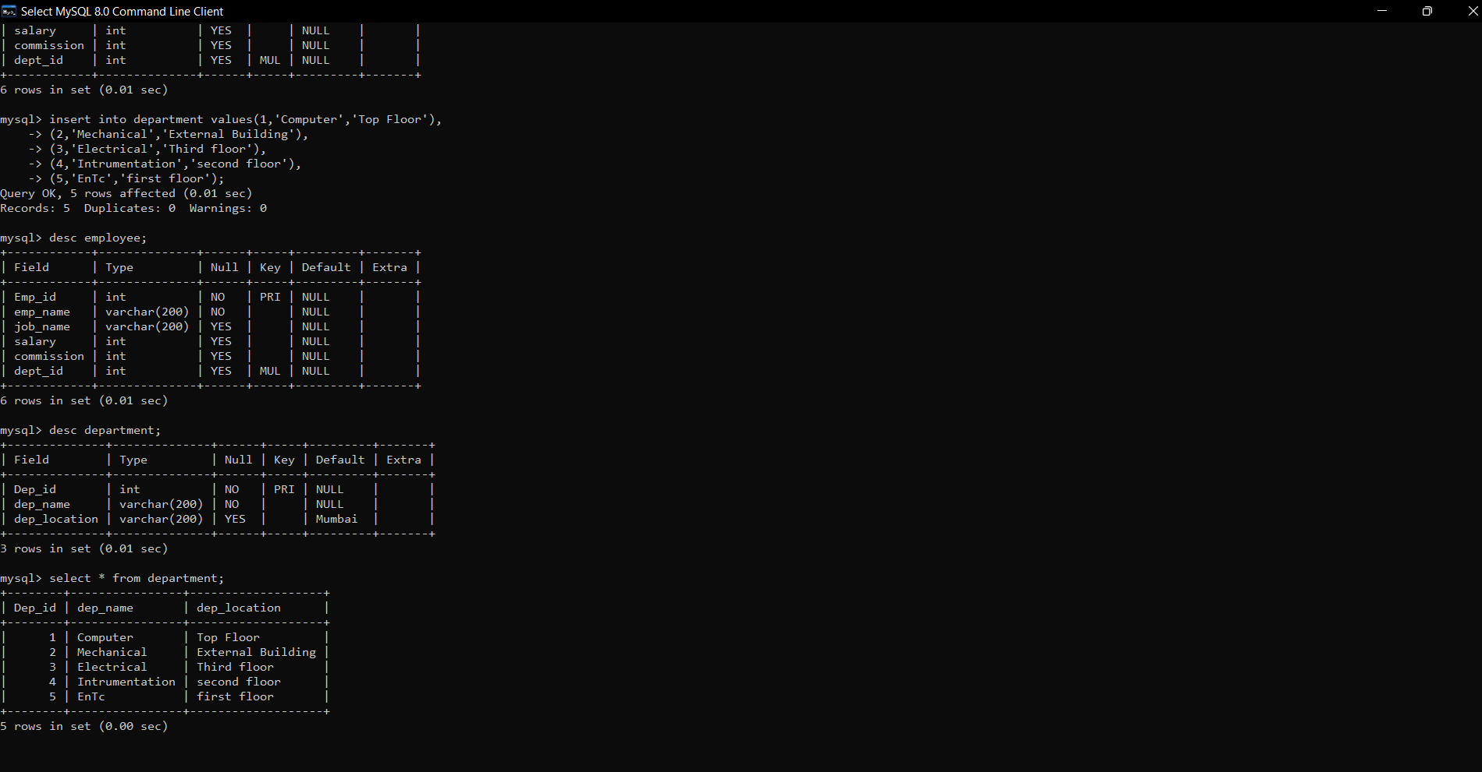

4. Insert 20 Different records in Employee table where few

employees can belong to same department

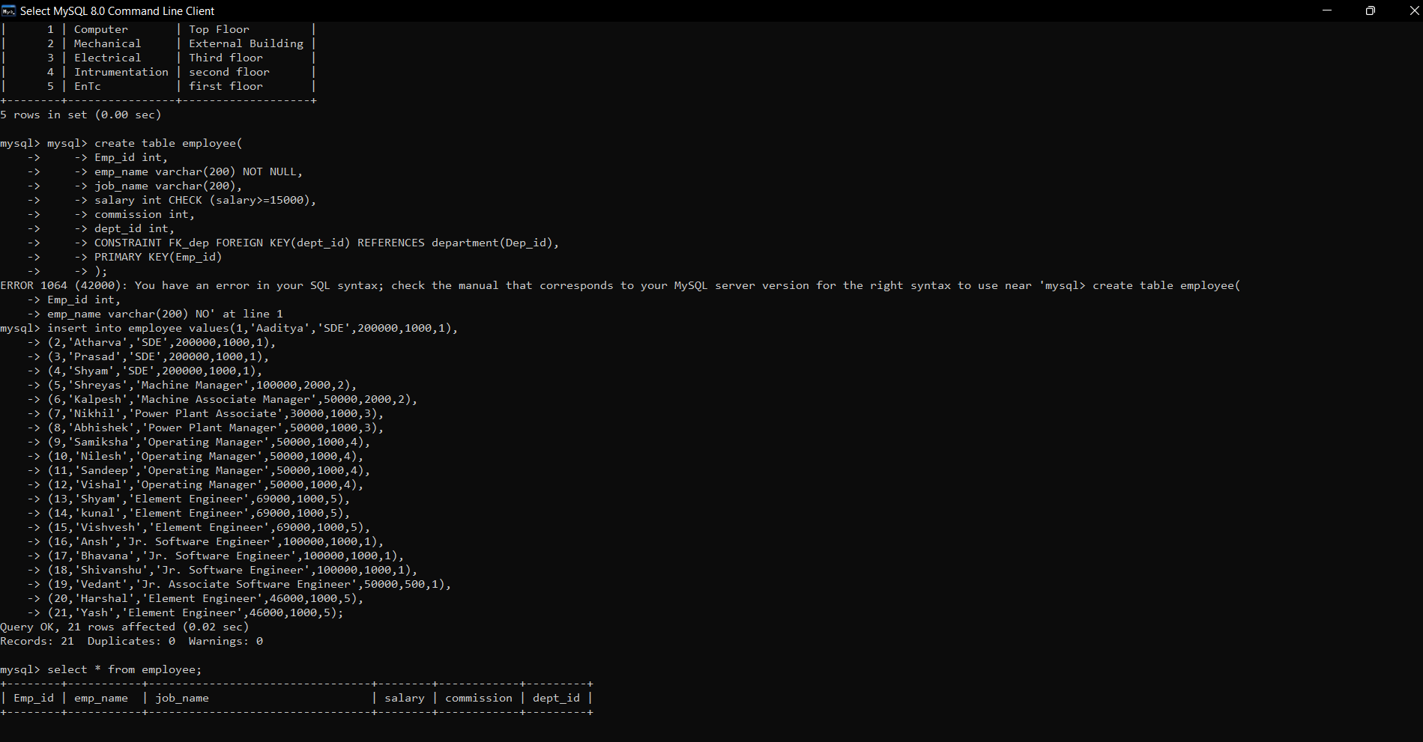

5. Display all the records from department table

Command=>select * from department;

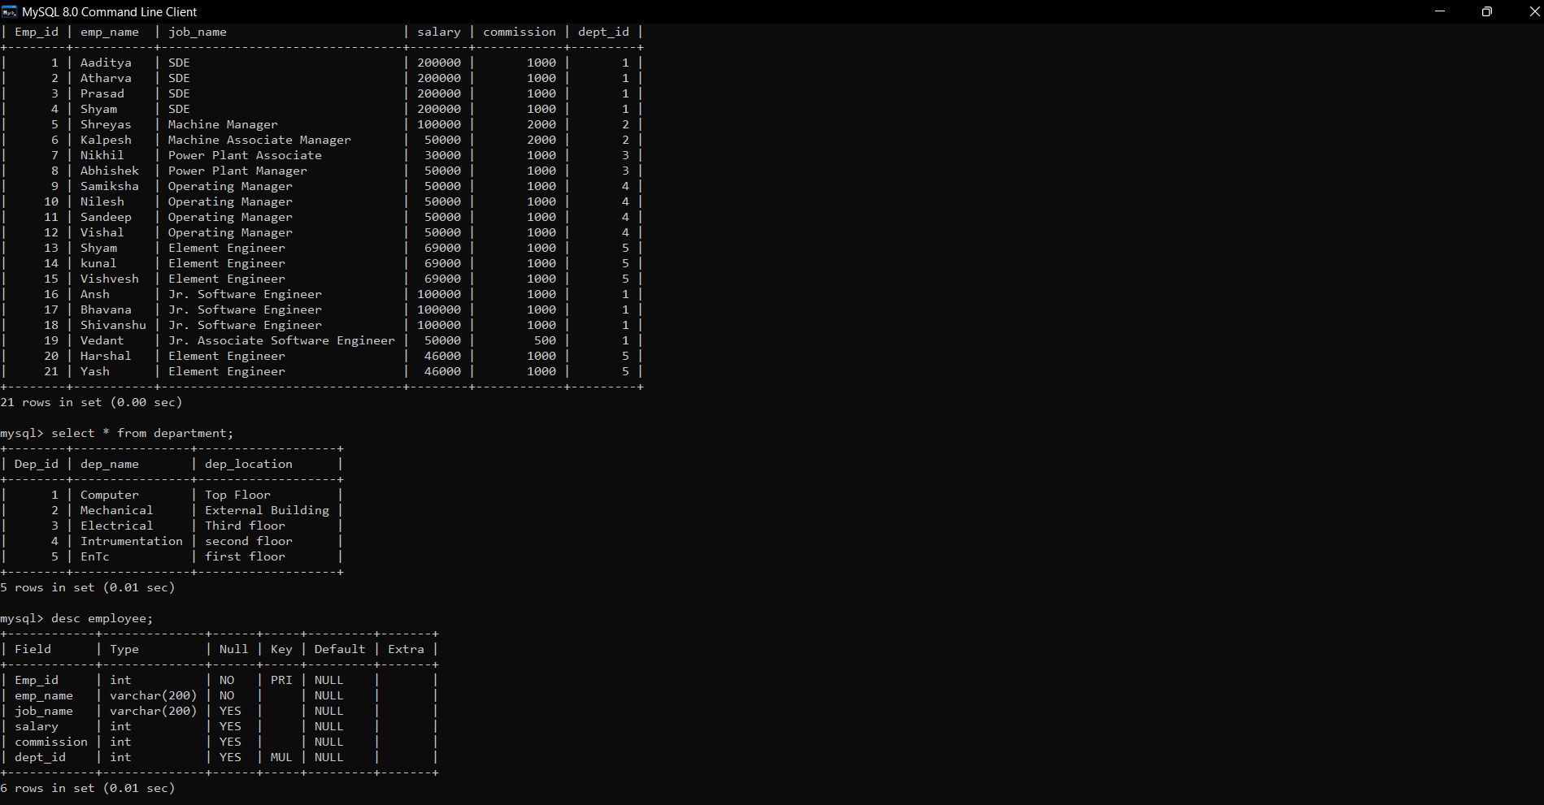

6. Update Department id to a new value to any existing department and

Command=> UPDATE department set Dep_id=6 where Dep_id=5;

7. Display all the records from employee table

Command=> select * from employee;

Same Answer:-

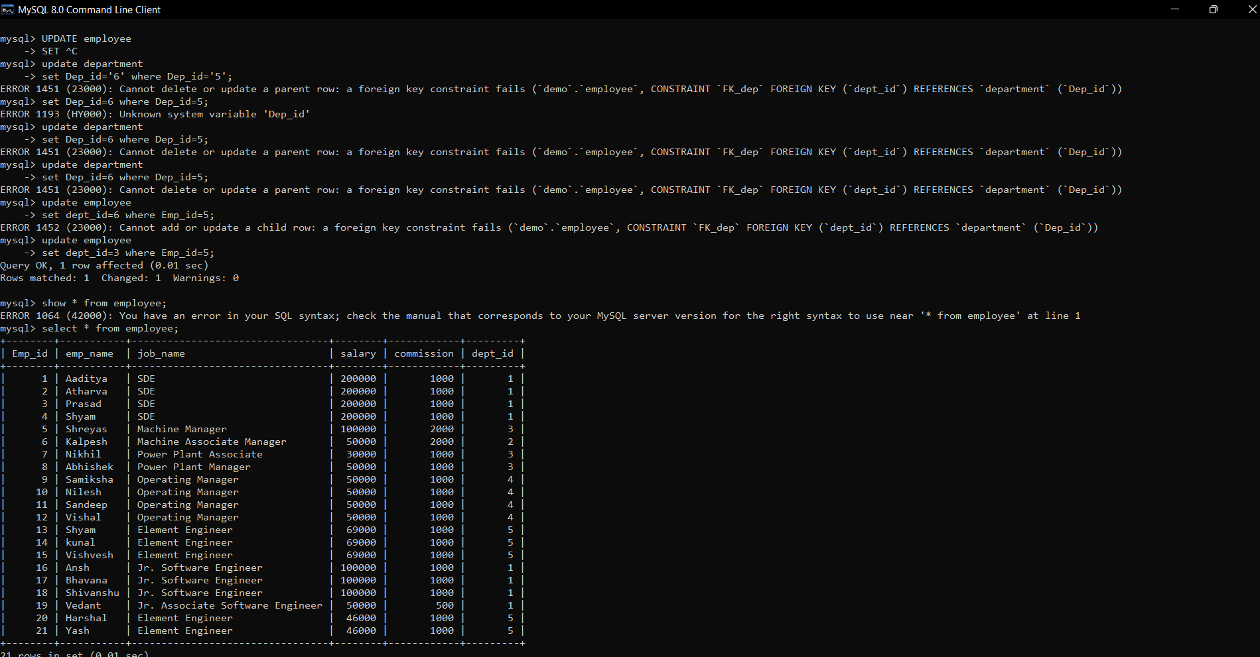

8. Display Employee ID and salary of all employees AND

Select Emp_id , salary from employee;



9. Display count of records from employee table AND

Command=> select COUNT(*) from employee;

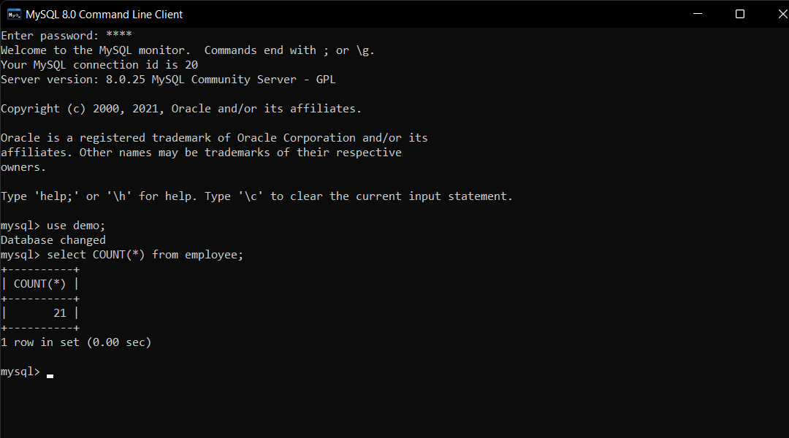

10. Display count of records from employee table for a particular department

Command=> select COUNT(*) from employee group by dept_id=1;

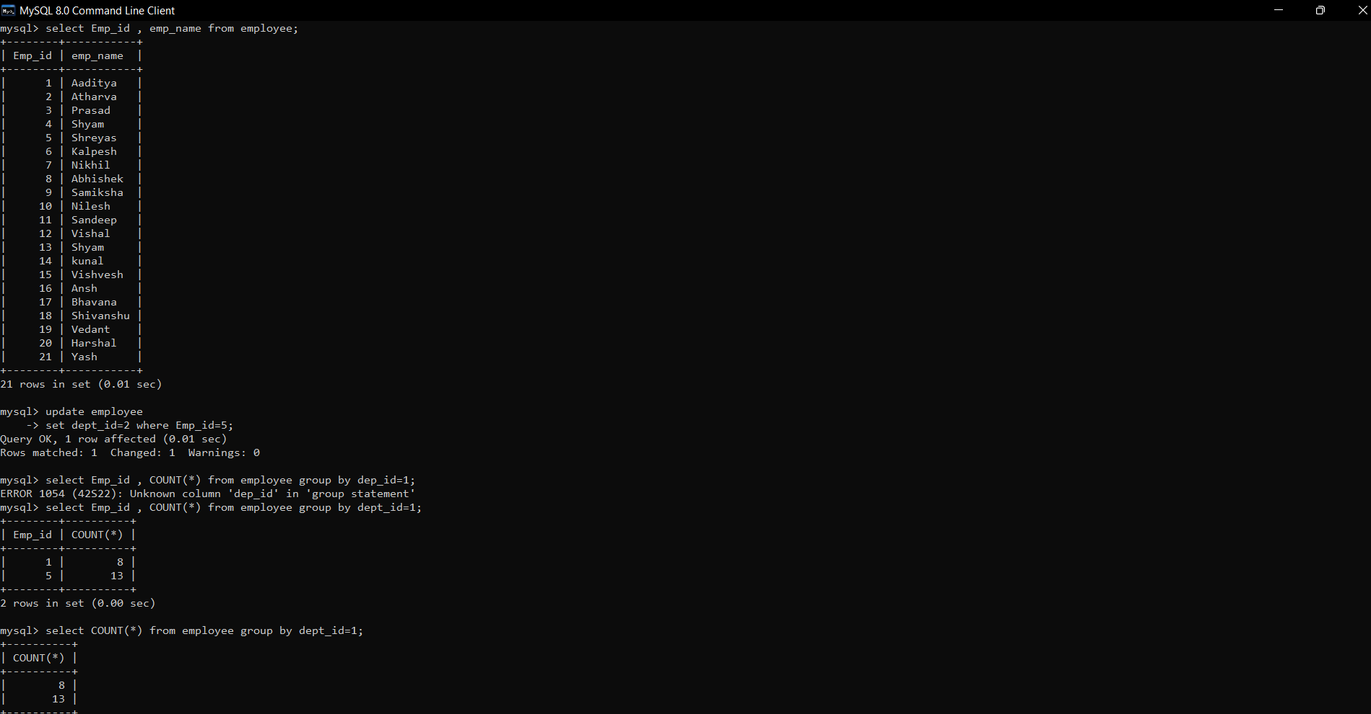

11. Add a new record in the Department Table and add new employee in that table with new department added in department table

Answer:- 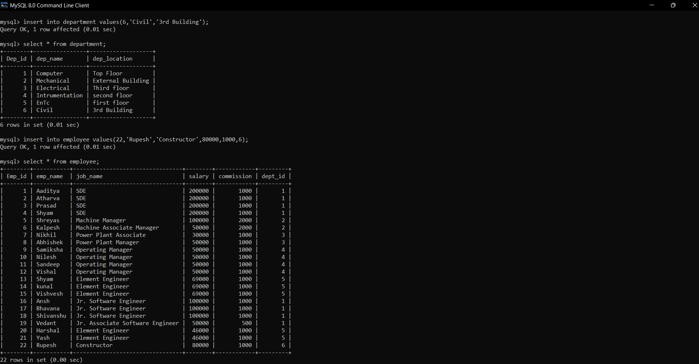

12. Find the max(salary) and min(salary) from employee table

Command=>

select emp_name , salary from employee where salary=(select max(salary) from employee);

select emp_name , salary from employee where salary=(select min(salary) from employee);

13. Find the avg(salary) from employee table

ANSWER:- select avg(salary) ,count(*) from employee;

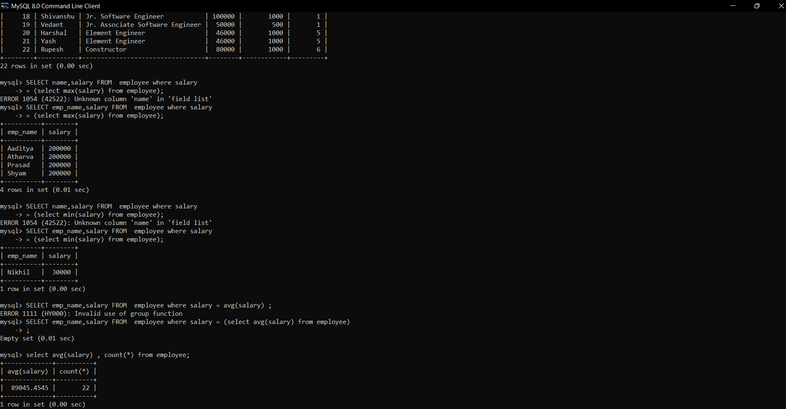

14. Try to delete a record from department table where employees are assigned to that department in the employee table

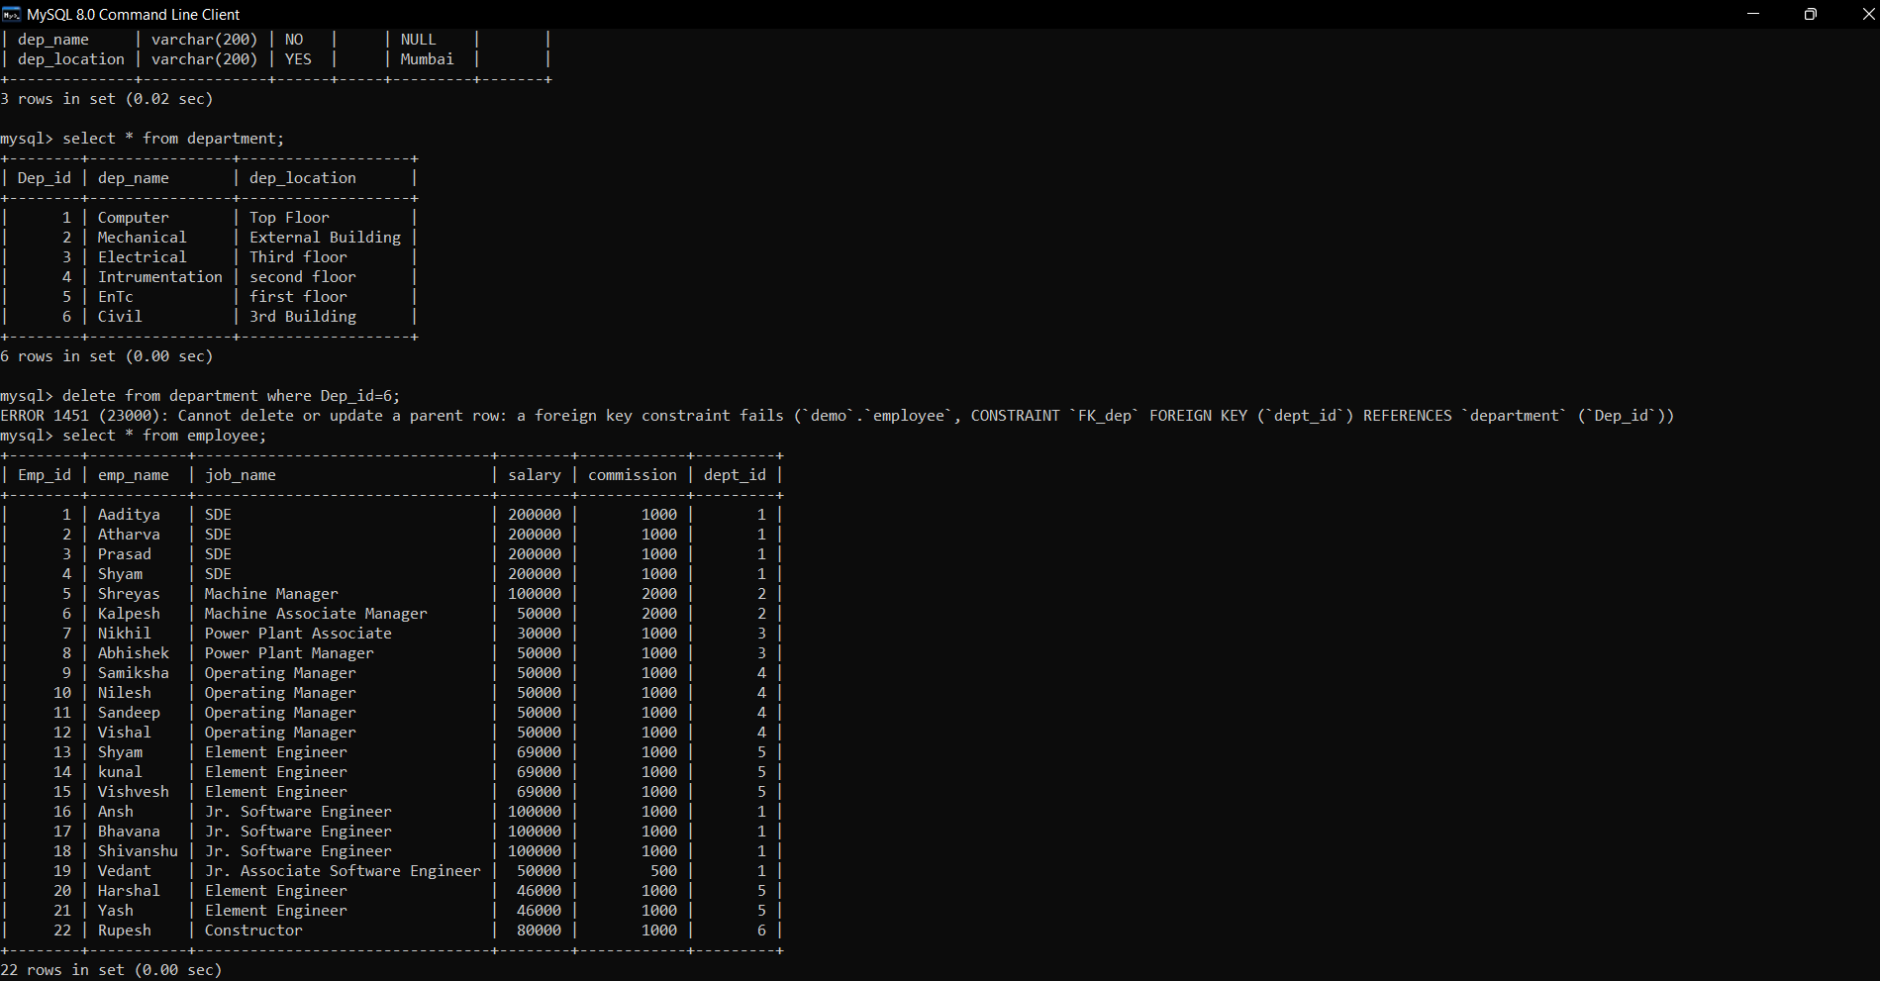

15. Try to delete the employee table record 1 st then delete that department from department table

Command=> delete from employee where dept_id = 6;

Delete from department where Dep_id=6;

